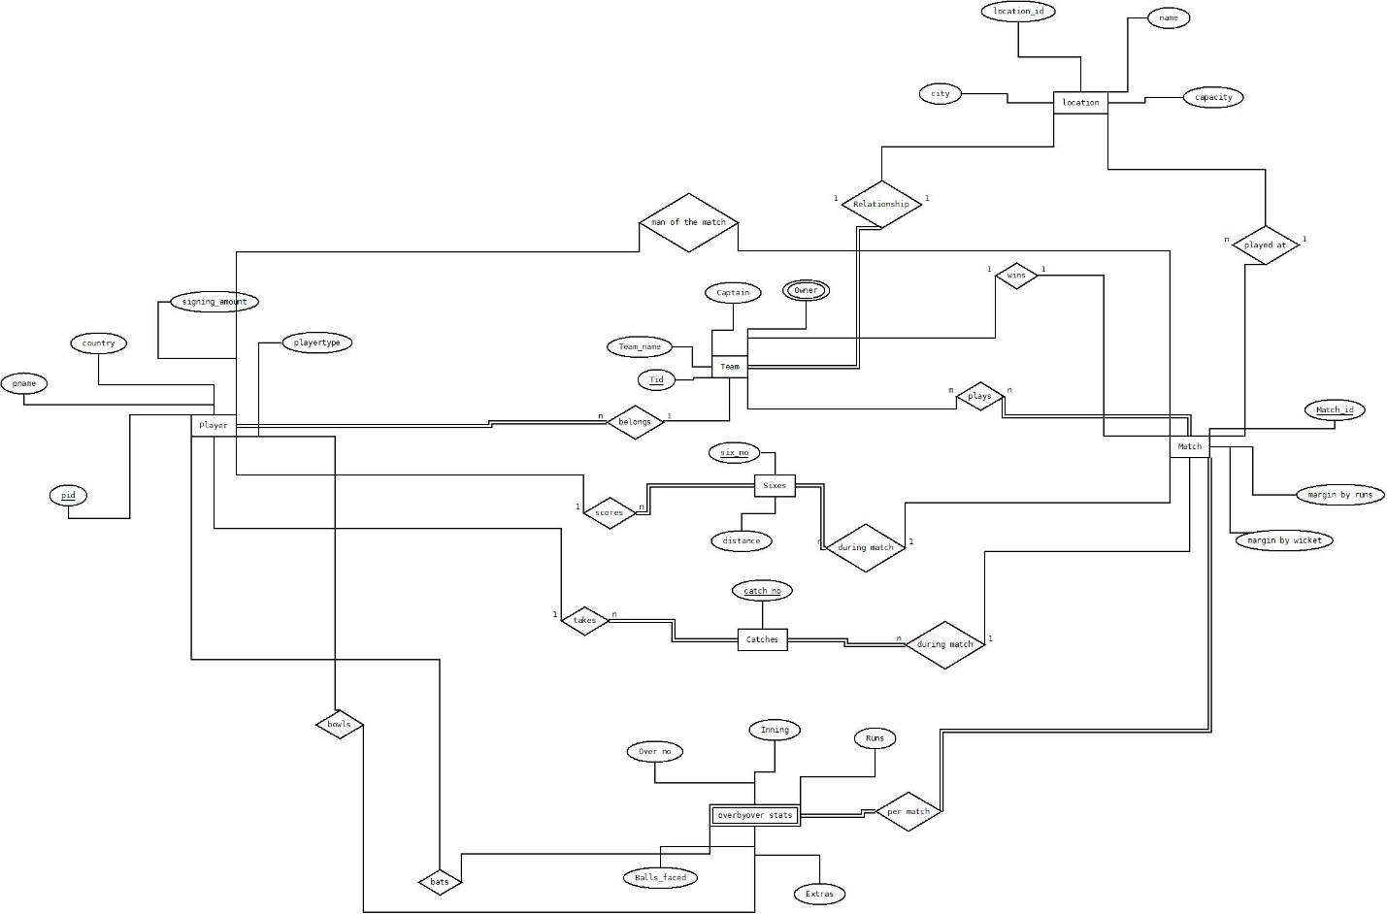

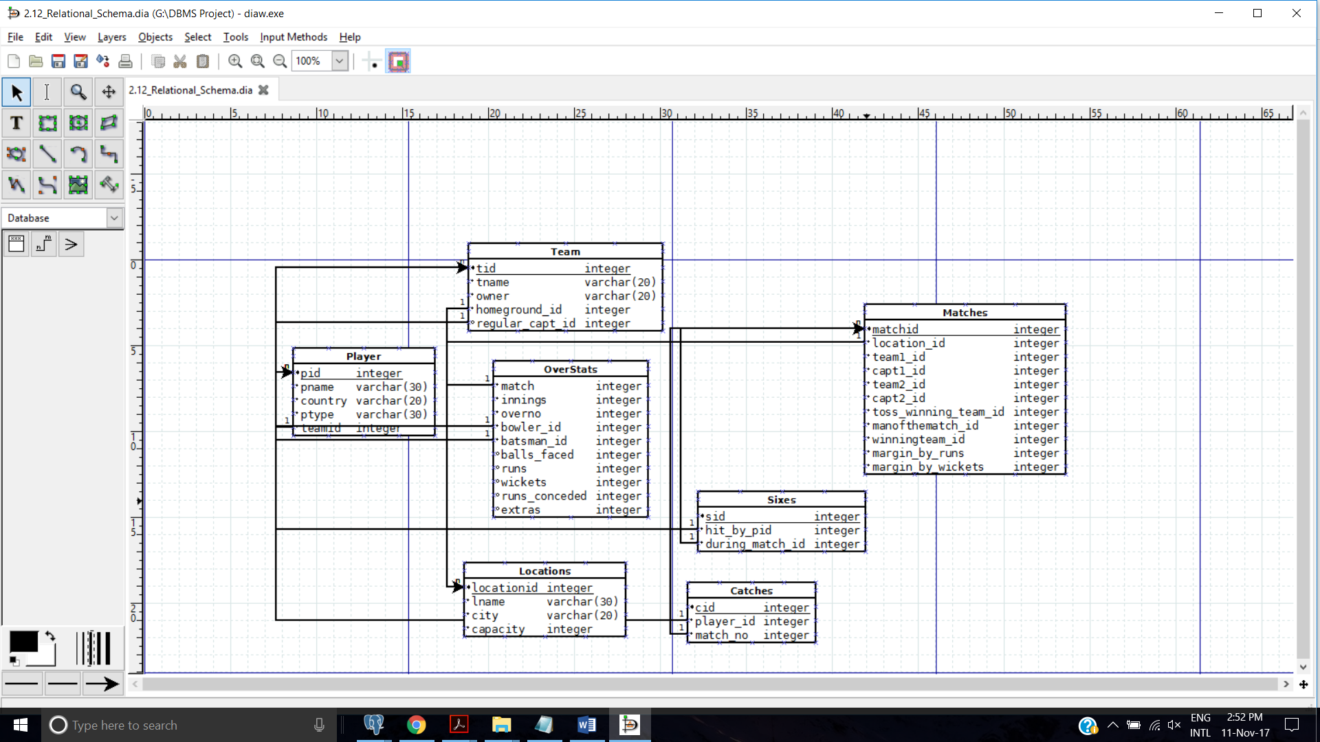

Table : location

locationid -> groundname

locationid -> city

locationid -> capacity

All non prime attributes are derived from primary key so

IN BCNF

Table : match

Matchid -> team1_id

Matchid -> captain1_id

Matchid ->team2_id

Matchid ->captain2_id

Matchid ->toss_winning_team_id

Matchid ->winningteam_id

Matchid ->margin_by_runs

Matchid ->margin_by_wickets

Matchid ->venue_id

Matchid ->man_of_the_match_id

All non prime attributes are derived from primary key so

IN BCNF

Table : player

Pid-> pname

Pid-> country

Pid-> ptype

Pid->teamid

Pid->auction_price

All non prime attributes are derived from primary key so

IN BCNF

Table : team

Tid->tname

Tid->owner

Tid->homeground_id

All non prime attributes are derived from primary key so

IN BCNF

Table : sixes

Sid->hit_by_pid

Sid->during_match_id

Sid->distance

All non prime attributes are derived from primary key so

IN BCNF

Table : catches

cid->player_id

cid->matchno

All non prime attributes are derived from primary key so

IN BCNF

Table : overstats

(match,innings,overno,batsman_id)->bowler_id

(match,innings,overno,batsman_id)->balls_faced

(match,innings,overno,batsman_id)->runs

(match,innings,overno,batsman_id)->wickets

(match,innings,overno,batsman_id)->extras

All non prime attributes are derived from primary key so

IN BCNF